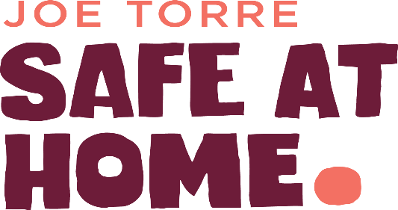
TEAM SAFE AT HOME
Sunday, November 1, 2026
New York City, NY
www.joetorre.org

THANK YOU FOR YOUR INTEREST IN TEAM SAFE AT HOME!

We are very excited to be a charity partner in the TCS New York City Marathon for 2026. We appreciate that you are making a personal goal of completing the TCS New York City Marathon this year and also dedicating your energy to raising funds for Margaret’s Place – our violence prevention and intervention model. These safe spaces provide intervention, counseling and empower young people to build resilience, learn coping skills, model healthy relationships, and become advocates to end the cycle.
SPECIAL NOTE REGARDING APPLICATION

Applications will be reviewed and runners will be notified by email if they are selected as a member of “Team Safe At Home”.

I hereby release and discharge Team Safe At Home, the Joe Torre Safe At Home Foundation and/or its agents, employees, representatives, officers, associates or affiliates, hereinafter referred to as the “Released Parties,” from and against any and all claims, demands, actions, damages, losses, costs, expenses and liabilities arising out of or in connection with my participation with the Joe Torre Safe At Home Foundation, Safe At Home events and Safe At Home activities in 2026. I further agree that I will not sue or make claim against any of the Released Parties for Damages or other losses sustained because of my participation in the Joe Torre Safe At Home Foundation’s “Team Safe At Home” events and activities. I understand that participating in a marathon is a physically demanding activity, and I confirm that I am in good health and prepared for the challenge of a marathon.

X
Signature Date

X
Signature of parent/legal guardian (if under 18) Date

PERSONAL INFORMATION

LAST NAME: |  | FIRST NAME: |  |  |  | TITLE (Mr., Mrs., Ms., Dr., etc.):
ADDRESS:

CITY: |  |  | STATE: |  | ZIP:
EMAIL: |  | HOME PHONE: |  |  | CELL PHONE:
GENDER: | DATE OF BIRTH: |  |  | OCCUPATION:
EMPLOYER:

HOW WOULD YOU DESCRIBE YOUR FITNESS LEVEL/RUNNING EXPERIENCE?

HAVE YOU EVER PARTICIPATED IN A HALF-MARATHON OR A MARATHON BEFORE? IF YES, WHEN AND WHAT WAS YOUR TIME?

ARE YOU ALREADY REGISTERED FOR THE 2026 TCS NEW YORK CITY MARATHON? IF YES, PLEASE INCLUDE YOUR ENTRANT #:

PREDICTED FINISH TIME:

ADDITIONAL INFORMATION

HOW DID YOU FIND OUT ABOUT TEAM SAFE AT HOME?

WHY DO YOU WANT TO JOIN TEAM SAFE AT HOME?

T-SHIRT SIZE: (e.g. XS, S, M, L, XL, XXL)
WHEN DO YOU EXPECT TO ARRIVE IN NEW YORK FOR THE RACE?
SOCIAL MEDIA HANDLES:
Facebook: @ Instagram: @

X: @ Linked In:

TEAM SAFE AT HOME PARTICIPATION DONATION

I, ________________________, pledge my commitment to Team Safe At Home and to the Joe Torre Safe At Home Foundation to raise no less than the minimum fundraising amount expected of me to take part in the 2026 TCS New York City Marathon. I understand that if my fundraising minimum of $3,000.00 has not been reached one week prior to race day (10/25/2026), that I am personally responsible to pay in full the remaining funds owed to reach the minimum fundraising commitment to participate in the 2026 TCS New York City Marathon. I have supplied my credit card information below and understand that on 10/25/2026 any remaining balance due to reach the $3,000.00 commitment will be charged to the credit card provided.

*If a runner does not reach their fundraising commitment to Team Safe At Home, they will be excluded from participating in the 2026 TCS New York City Marathon but would be allowed to seek entry to future races. *Credit card will only be charged if the amount to complete the fundraising minimum is not reached by 10/25/2026.

FULL NAME AS IT APPEARS ON CARD:

CARD TYPE (circle one):  VISA MASTERCARD AMEX DIS |  | CARD NUMBER:
EXPIRATION DATE: | CVR CODE (on back): |  | SIGNATURE:

SUBMIT YOUR APPLICATION

Thank you for your interest in joining Team Safe At Home! Please send us your application using one of the methods below. We look forward to having you as a member of our team! If you have any questions, please call Ann Dean at 212.880.7373.

MAIL: FAX: SCAN or EMAIL:
Ann Dean Attn: Ann Dean Ann Dean
Joe Torre Safe at Home Foundation 212.560.8919 contact@joetorre.org
55 W. 39th Street Suite 600
New York, NY 10018

